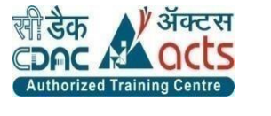

INSTITUTE FOR ADVANCED COMPUTING AND SOFTWARE DEVELOPMENT AKURDI, PUNE



**Documentation on**

**Dairy Delight**

**“Online Milk Product E-Commerce Store”**

**PG-DAC Sept 2022**

**Submitted By:**

**Roll no: Name:**

**229174 Namita Dewangan**

**229162 Kavita**

**Centre Co-Ordinator : Project Guide:**

**Mr. Rohit Puranik Mrs. Rupali Thorat**

**ABSTRACT**

This project is a web-based shopping system for an existing shop. The project objective is to deliver the online shopping application into web platform.

This project is an attempt to provide the advantages of online shopping to customers of a real shop. It helps buying the products in the shop anywhere through internet by using a website device. Thus, the customer will get the service of online shopping and home delivery from his favourite shop. This system can be implemented to any shop in the locality or to multinational branded shops having retail outlet chains.

If shops are providing an online portal where their customers can enjoy easy shopping from anywhere, the shops won’t be losing any more customers to the trending online shops such as Flipkart or e-bay. Since this application is available in the Smartphone it is easily accessible and always available

**ACKNOWLEDGEMENT**

I take this occasion to thank God, almighty for blessing us with his grace and taking our endeavour to a successful culmination. I extend my sincere and heartfelt thanks to our esteemed guide, **Mrs. Rupali Thorat** for providing me with the right guidance and advice at the crucial juncture sand for showing me the right way. I extend my sincere thanks to our respected **Centre Co-Ordinator** **Mr. Rohit Puranik** for allowing us to use the facilities available. I would like to thank the other faculty members also, at this occasion. Last but not the least, I would like to thank my friends and family for the support and encouragement they have given me during the course of our work.

Namita Dewangan (229174)

Kavita (229162)

**Table of Contents**

**ABSTRACT………………………………………………………………………………………2**

**ACKNOWLEDGEMENT……………………………………………………………………….3**

**INTRODUCTION………………………………..………………………………………………5**

**FEATURES……………………………………………………………………………………….5**

* 1. **PROJECT OBJECTIVE…….………………………………..……..………………6**
  2. **PROJECT OVERVIEW…………………..…………………………………………6**
  3. **PROJECT SCOPE………………….…….………………………………….……….6**
  4. **STUDY OF SYSTEM…………………….…………………………………………..7**
     1. **MODULES………………………………………………………………………..7**
     2. **REGISTRATION ACTIVITY DIAGRAM………………...…………………..8**
     3. **LOGIN ACTIVITY DIAGRAM…………………………………..……………9**
     4. **SEARCH ACTIVITY DIAGRAM……………………………………….……11**
     5. **ADD TO CART ACTIVITY DIAGRAM…………………………….………12**
     6. **PAYMENT ACTIVITY DIAGRAM……………………………………….…13**
     7. **SYSTEM ANALYSIS........................................................................................ 15**
     8. **2.1 EXISTING SYSTEM ........................................................................................... 15**
     9. **2.2 PROPOSED SYSTEM ........................................................................................ 15**
     10. **2.3 SYSTEM REQUIREMENT SPECIFICATION............................................... 16**
     11. **2.3.1 GENERAL DESCRIPTION............................................................................ 16**
     12. **2.3.2 FUNCTIONAL REQUIREMENTS .............................................................. 17**
     13. **2.3.3 NON FUNCTIONAL REQUIREMENTS...................................................... 18**
     14. **MODERATOR......................................................................................................... 20**
     15. **DESCRIPTION OF FEATURES........................................................................... 20**
     16. **ADMIN ..................................................................................................................... 21**
     17. **SYSTEM DESIGN................................................................................................... 22**
     18. **3.1 INPUT AND OUTPUT DESIGN ................................................................... 22**
     19. **3.1.1 INPUT DESIGN ........................................................................................... 22**
     20. **3.1.2 OUTPUT DESIGN ....................................................................................... 22**
     21. **DATABASE DESIGN ........................................................................................... 24**
     22. **3.2 DATABASE....................................................................................................... 24**
     23. **3.3 SYSTEM TOOLS ............................................................................................ 24**
     24. **3.3.1 FRONT END................................................................................................... 24**
     25. **3.3.2 BACKEND ...................................................................................................... 24**
     26. **USECASE DIAGRAM……………………………………………………………..26**
     27. **SEQUENCE DIAGRAM…………………………………………………………..27**
     28. **SEARCH ITEM IN CATELOG………………………………………………..…27**
     29. **ADD ITEM SEQUENCE DIAGRAM…………………………………………….28**
     30. **DEPLOYMENT DIAGRAM………………………………………………………30**
     31. **SCREENSHOTS…………………………………………………………………31-36**
     32. **0 LEVEL DFD .......................................................................................................... 37**
     33. **CLASS DIAGRAM…………………………………………………………………38**
     34. **E-R DIAGRAM......................................................................................................... 40**
     35. **TABLE STRUCTURE ............................................................................................. 41-45**

**INTRODUCTION**

This project is a web-based shopping system for an existing shop. An Online dairy Product Shopping Management System where the Admin can Add, Update and Delete products. The Products are divided into various categories like Milk, Butter, Paneer, etc. A user can select a particular item to view the details, choose the number of items and fill in details like name etc. to buy a product. The project objective is to deliver the online shopping application into web platform. Online shopping is the process where consumers directly buy products or services from a seller in real- time, without an intermediary service, over the Internet. It is a form of Ecommerce. This project is attempts provide the advantages of online shopping to customers of a real shop. It helps buying the products in the shop anywhere through internet by using an android device. Thus, the customer will get the service of online shopping and home delivery from his favourite shop.

The objective of the project is to make an application in android platform to purchase items in an existing shop. In order to build such an application complete web support, need to be provided. A complete and efficient web application which can provide the online shopping experience is the basic objective of the project. The web application can be implemented in the form of an android application with web view.

**Features**:-

1. Products Available- Milk, Paneer, Butter, Lassi.

2. Search for Products (Milk, Butter) products easily

3. Category of products- Milk, Butter, Paneer, Lassi,

4. Cart feature

5. Date and time of product delivery will be notified by the system

6. The admin can add/delete Products.

7. Allows the customers to Order items.

* 1. **PROJECT OBJECTIVE**

The objective of the project is to make an application in android platform to purchase items in an existing shop. In order to build such an application complete web support, need to be provided. A complete and efficient web application which can provide the online shopping experience is the basic objective of the project. The web application can be implemented in the form of an android application with web view.

* 1. **PROJECT** **OVERVIEW**

The central concept of the application is to allow the customer to shop virtually using the internet and allow customers to buy the items and articles of their desire from the store. The information pertaining to the products are stores on an RDBMS at the server side (store).

The server processes the customers, and the items are shipped to the address submitted by them. The application was designed into two modules first is for the customers who wish to buy the articles. Second is for the storekeepers who maintains and updates the information pertaining to the articles and those of this product is a departmental store where the application is hosted on the web and the administrator maintains the database. The application, which is deploy the customer database, the details of the items are brought forward from the database for the customer view based on the selection through the menu and the database of all the products are updated at the end of each transaction. Data entry into the application can be done through various screens designed for various levels of users. Once the authorized personal feed the relevant data into the system, several reports could be generated as per the security.

* 1. **PROJECT SCOPE**

This system can be implemented to any shop in the locality or to multinational branded shops having retail outlet chains. The system recommends a facility to accept the orders 24X7 and a home delivery system which can make customers happy. If shops are providing an online portal where their customers can enjoy easy shopping from anywhere, the shops won’t be losing any more customers to the trending online shops such as FlipKart or eBay. Since the application is available and always available.

* 1. **STUDY OF THE SYSTEM**
     1. **MODULES**

The system after careful analysis has been identified to be presented with the following modules and roles.

The modules involved are:

➢ Administrator

➢ Shopping Cart

➢ Users

➢ Order

* + - 1. Administrator:

The administrator is the super user of this application. Only admin have access into this admin page. Admin may be the owner of the shop. The administrator has all the information about the users and about all products.

This module is divided into different sub modules.

1. Manage Users

2. Manage Products

3. Manage Orders

**Activity Diagrams:-**

**Registration Activity Diagram**

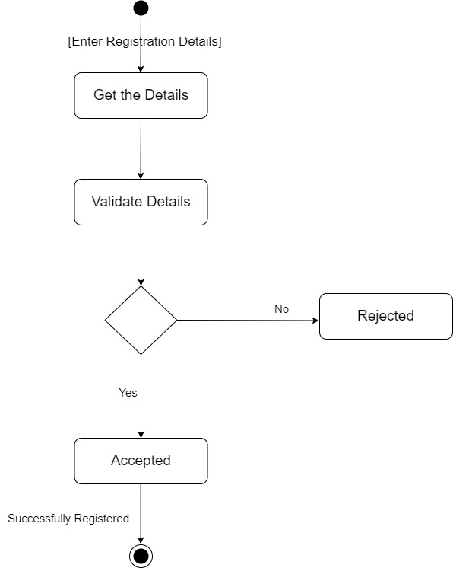

**Login Activity Diagram**

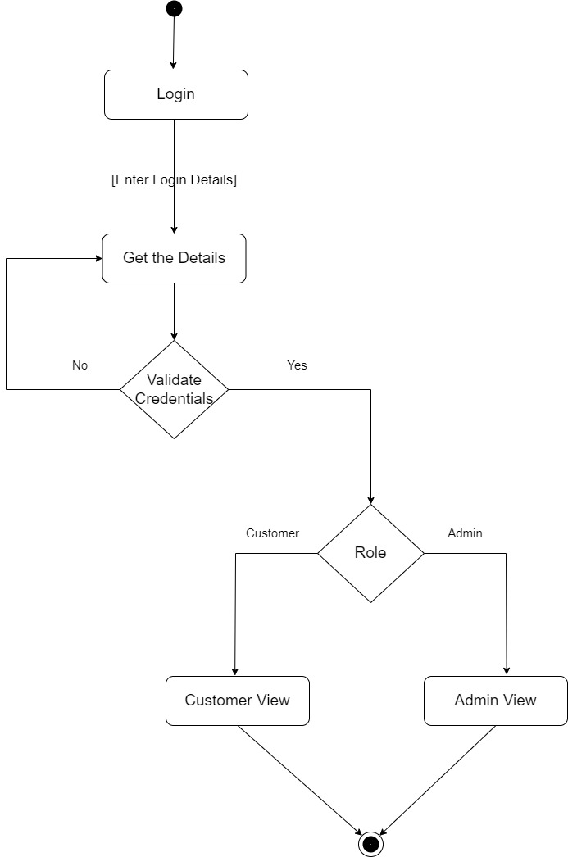

**➢ Add Products**

The shopping cart contains different kinds of products of different category. The products

can be classified into different categories by name. Admin can add new products into the

existing system with all its details including an image.

**➢ Delete Products**

Admin can delete the products based on the stock of that particular product.

**➢ Search Products**

Admin will have a list view of all the existing products. He can also search for a

particular product by name.

**➢ Edit Product**

Admin can edit his added product.

➢ **Payments**

Admin can see payment details of the ordered product by the customer.

**Search Item Activity Diagram**

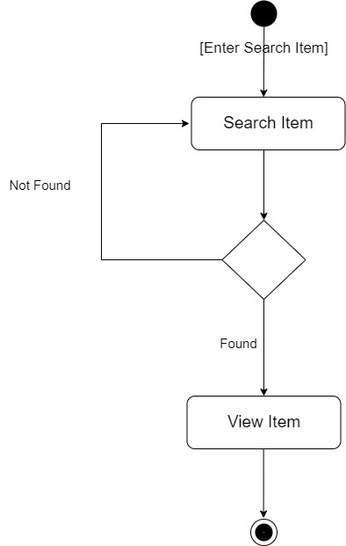

**Add to cart Activity Diagram**

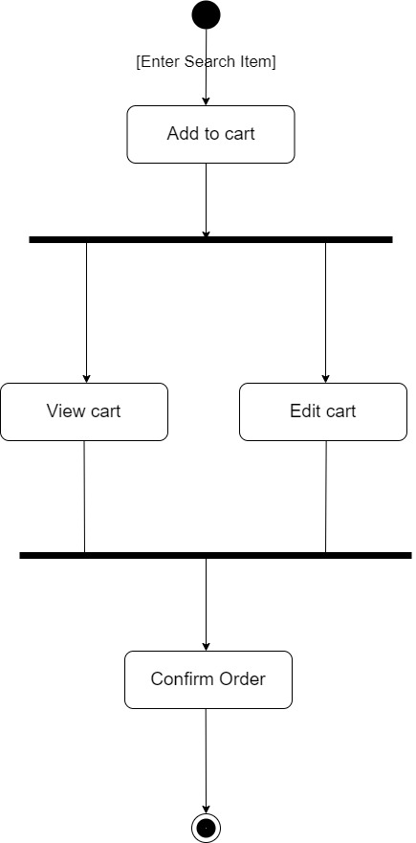

**Payment Activity Diagram**

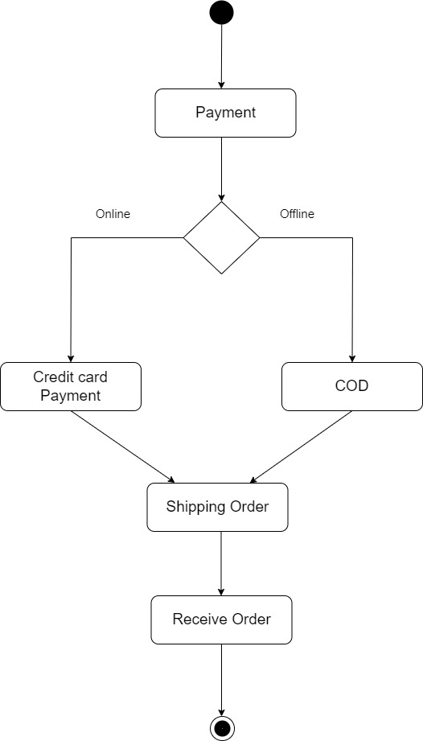

➢ **Customer sign in, sign out, create account**

This feature is provided to customer so they can sign in, sign out and create account

for new customer.

➢ **Search Product**

Customer can search the product as per his wish in specific category.

➢ **Add to Cart**

Customer can add products to cart which he wants to buy the products.

➢ **Payments**

Customer have a privilege to his order he can see his order details.

➢ **Order Details**

Customer have a privilege to his order he can see his order details.

➢ **Buy Product**

Customers can buy product from their cart by doing payment.

**SYSTEM ANALYSIS**

System analysis is the process of gathering and interpreting facts, diagnosing problems and using the information to recommend improvements on the system. System analysis is a problem-solving activity that requires intensive communication between the system users and system developers.

System analysis or study is an important phase of any system development process. The system is viewed as a whole, the inputs are identified, and the system is subjected to close study to identify the problem areas. The solutions are given as a proposal. The proposal is reviewed on user request and suitable changes are made. This loop ends as soon as the user is satisfied with the proposal.

**2.1 EXISTING SYSTEM**

The current system for shopping is to visit the shop manually and from the available product choose the item that customer wants and buying the item by payment of the price of the item.

✓ It is less user-friendly.

✓ User must go to shop and select products.

✓ It is difficult to identify the required product.

✓ Description of the product limited.

✓ It is a time-consuming process

✓ Not in reach of distant users.

**2.2 PROPOSED SYSTEM**

In the proposed system customer need not go to the shop for buying the products. He can order the product he wish to buy through the application in his Smartphone. The shop owner will be admin of the system. Shop owner can appoint moderators who will help owner in managing the customers and product orders. The system also recommends a home delivery system for the purchased products.

**2.3 SYSTEM REQUIREMENT SPECIFICATION**

**2.3.1 GENERAL DESCRIPTION:**

**Objective (Purpose):**

The Dairy Products Online Portal application deals with maintaining the inventory details of various dairy products and the billing process with great ease. As we want the work to be done at a faster rate. So this application will help in reducing the pen paper transaction to computerized transaction. This application will help in storing the products records like dairy products, employee records, customers records and purchase information in an easy and well organised manner.

**Scope:**

This System allows Shoppers to maintain their products for adding or removing from catalogue based on their availability. Customer will be able to review orders history and may able to cancel order within 24 hours, order place.

**Definitions:**

QA: Quality Assurance

Portal: Personalized Online Web Application

MIS: Management Information System

CRM: Customer Relation Management

BI: Business Intelligence

**Functional Requirements:**

Any anonymous User will be able to view different dairy products available for sale. Any User will be able to select products to view from categories available. Admin will be able to promote products for sale by adding products to the product catalogue maintained by System. Customer will be notified about order status, delivery status through Email communication. Customer will get complete information about their orders, likes, comments, details through a dashboard.

Administrator Panel:-

* Manage login process to allow the authenticated user to access the admin, customer, and dairy products.
* Create and manage (update/delete) customer account.
* Manage (Add/update/delete) dairy products.
* Keep the record of customer order and status.
* Manage customer order history.
* Update order status (Pending / Delivered / etc)
* Inventory management record.
* Keep a record of customer feedback.

Customer panel:-

* Register/ Login/ Forgot Password.
* Manage account.
* View past orders.
* View all listed products:
  + Eg: Milk, Paneer, Ghee, Sweets, Curd, Yogurt, Icecream etc.
  + Sorting of listed products (by price, alphabet)
* Cart – CRUD operations
* Cart Checkout
* Payment Page
* Payment Confirmation – Thank You Page
* Submit feedback.

**Non-Functional Requirement:**

**Security**

Registered Customer will be allowed to place order. Each stakeholder will be able to access system through authentication process. Who are you ? System will provide access to the content, operations using Role based security (Authorization) (Permissions based on Role) Using SSL in all transactions which will be performed stakeholder. It would protect confidential information shared by system to stake holder of Shared by stakeholder to system. System will automatically log of all stakeholder after some time due to inactiveness. System will block operations for inactive stakeholder and would redirect for authentication. System will internally maintain secure communication channel between Servers (Web Servers, App Servers, database Server) Sensitive data will be always encrypted across communication. User proper firewall to protect servers from outside fishing, vulnerable attacks.

**Reliability**

The system will backup business data on regular basis and recover in short time duration to keep system operational, continuous updates are maintained and continuous Administration is done to keep system operational. During peak hours system will maintain same user experience by managing load balancing.

**Availability**

uptime: 24* 7 available 99.999%

**Maintainability:**

A Commercial database software will be used to maintain System data Persistence. A readymade Web Server will be installed to host online Dairy Portal (Web Site) to management server capabilities. IT operations team will easily monitor and configure System using administrative tools provided by Servers. Separate environment will be maintained for system for isolation in production, testing, and development.

**Portability:**

PDA: Portable Device Application System will provide portable User Interface (HTML, CSS, JS) through users will be able to access online Dairy Portal. System can be deployed to single server, multi-server, to any OS, Cloud (Azure or AWS or GCP)

**Accessibility:**

Only registered customer will be able to place an order after authentication. Sales team can reject or approve orders, shopper requests based on role provided. Admin will be able to see products sale graph.

**Durability:**

System will retain customer shopping cart for 15 minutes even though customer loose internet connection and join again. System will maintain Wishlist for customer. Customer will be able to add products from Wishlist and add to shopping cart whenever needed. System will implement backup and recovery for retaining stake holders’ data, business operation data and business data over time.

**Efficiency:**

on Festival season, maximum number of users will place order, view products with same response time. System will be able to manage all transactions with isolation.

**Modularity:**

System will be designed and developed using reusable, independent or dependent business scenarios in the form of modules. These modules will be loosely coupled and highly cohesive. System will contain CRM, Inventory, shopping cart, order processing, payment processing, Delivery module, membership and Roles management modules.

**Scalability:**

System will be able to provide consistent user experience to stake holder as well as visitors irrespective of load.

**Safety:**

Dairy Delight online Portal will be secured from malicious attack, phishing. Dairy Delight shopping portal functionalities are protected from outsiders with proper firewall configuration. online shopping portal will be always kept updated with latest antivirus software. Business data will be backed up periodically to ensure safety of data using incremental back up strategy. Role based security will be applied for Application data and operations accessibility.

**MODERATOR**

**Description of features**

A moderator is considered as a staff who can manage orders for the time being. As a future update

moderator may give facility to add and manage his own products. Moderators can reduce the

workload of admin. Now moderator has all the privilege of an admin having except managing

other moderators. He can manage users and manage products. He can also check the orders and

edit his profile.

**Functional Requirement**

• The system must identify the login of a moderator.

**ADMIN**

**➢ MANAGE USER**

Description of features

The administrator can add user, delete user, view user and block user.

**➢ MANAGE MODERATOR**

**Description of features**

The administrator can add moderator, delete moderator, block moderator and search for a

moderator.

**➢ MANAGE PRODUCTS**

**Description of features**

The administrator can add product, delete product, and view product.

**➢ MANAGE ORDER**

**Description of features**

The administrator can view orders and delete orders.

**Functional Requirements:**

• The system must identify the login of the admin.

• Admin account should be secured so that only owner of the shop can access that account.

**MODERATOR**

**Description of features**

A moderator is considered as a staff who can manage orders for the time being. As a future

update moderator may give facility to add and manage his own products. Moderators can reduce

the workload of admin. Now moderator has all the privilege of an admin having except

managing other moderators. He can manage users and manage products. He can also check the

orders and edit his profile.

**Functional Requirement**

• The system must identify the login of a moderator.

**SYSTEM DESIGN**

System design is the solution for the creation of a new system. This phase focuses on the detailed

implementation of the feasible system. Its emphasis on translating design. Specifications to

performance specification. System design has two phases of development.

➢ Logical Design

➢ Physical Design

During logical design phase the analyst describes inputs (sources), outputs(destinations), databases

(data sores) and procedures (data flows) all in a format that meets the user requirements. The

analyst also specifies the needs of the user at a level that virtually determines the information flow

in and out of the system and the data resources. Here the logical design is done through data flow

diagrams and database design. The physical design is followed by physical design or coding.

Physical design produces the working system by defining the design specifications, which specify

exactly what the candidate system must do. The programmers write the necessary programs that

accept input from the user, perform necessary processing on accepted data and produce the

required report on a hard copy or display it on the screen.

**3.1 INPUT AND OUTPUT DESIGN**

**3.1.1 INPUT DESIGN:**

Input design is the link that ties the information system into the world of its users. The input design

involves determining the inputs, validating the data, minimizing the data entry and provides a

multi-user facility. Inaccurate inputs are the most common cause of errors in data processing.

Errors entered by the data entry operators can be controlled by input design. The user-originated

inputs are converted to a computer-based format in the input design. Input data are collected and

organized into groups of similar data. Once identified, the appropriate input media are selected for

processing. All the input data are validated and if any data violates any conditions, the user is

warned by a message. If the data satisfies all the conditions, it is transferred to the appropriate

tables in the database. In this project the student details are to be entered at the time of registration.

A page is designed for this purpose which is user friendly and easy to use. The design is done such

that users get appropriate messages when exceptions occur.

**3.1.2 OUTPUT DESIGN**:

Computer output is the most important and direct source of information to the user. Output design

is a very important phase since the output needs to be in an efficient manner. Efficient and

intelligible output design improves the system relationship with the user and helps in decision

making. Allowing the user to view the sample screen is important because the user is the ultimate

judge of the quality of output. The output module of this system is the selected notifications.

**DATABASE DESIGN**

**3.2 DATABASE**

Databases are the storehouses of data used in the software systems. The data is stored in tables

inside the database. Several tables are created for the manipulation of the data for the system. Two

essential settings for a database are

▪ Primary key - the field that is unique for all the record occurrences

▪ Foreign key - the field used to set relation between tables

Normalization is a technique to avoid redundancy in the tables.

**3.3 SYSTEM TOOLS**

The various system tools that have been used in developing both the front end and the back end of

the project are being discussed in this chapter.

**3.3.1 FRONT END:**

React is a library which is developed by Facebook are utilized to implement the frontend. React

(also known as React.js or ReactJS) is a free and open-source front-end JavaScript library for

building user interfaces or UI components. It is maintained by Facebook and a community of

individual developers and companies. React can be used as a base in the development of single

page or mobile applications. However, React is only concerned with state management and

rendering that state to the DOM, so creating React applications usually requires the use of

additional libraries for routing, as well as certain client-side functionality.

**3.3.2 BACKEND:**

The back end is implemented using MySQL which is used to design databases.

**MySQL:**

MySQL is the world's second most widely used open-source relational database management

system (RDBMS). The SQL phrase stands for Structured Query Language. An application

software called Navicert was used to design the tables in MySQL.

**Spring-Boot:**

This is used to connect MYSQL and fetch data from database and store the data in database. The

Spring Framework is an application framework and inversion of control container for the Java

platform. The framework's core features can be used by any Java application, but there are

extensions for building web applications on top of the Java EE (Enterprise Edition) platform.

Although the framework does not impose any specific programming model, it has become popular

in the Java community as an addition to the Enterprise JavaBeans (EJB) model. The Spring

Framework is Open-source Framework.

**UseCase Diagram**

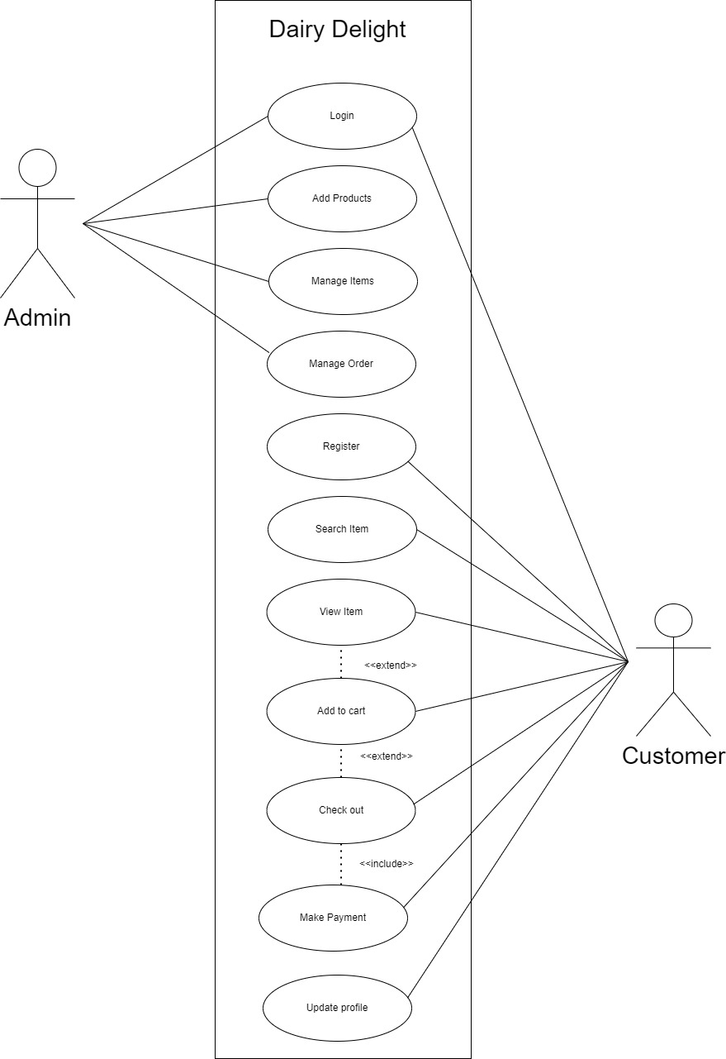

**Sequence Diagram:**

**Search item in catelog**

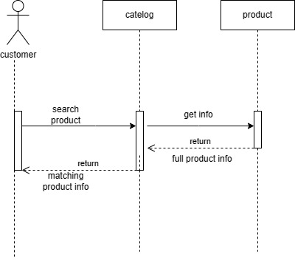

**Add item into cart**

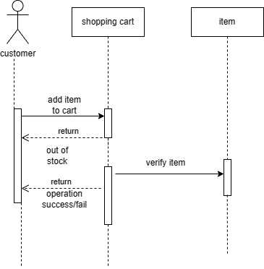

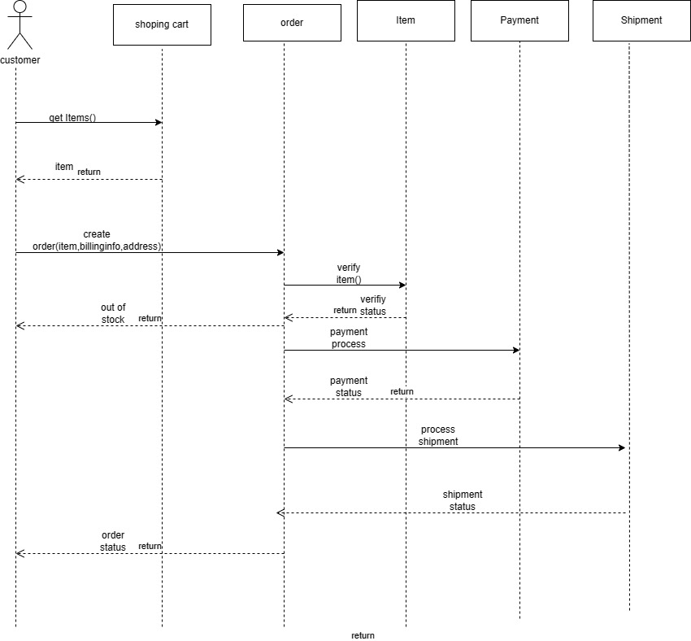

**Deployment Diagram**

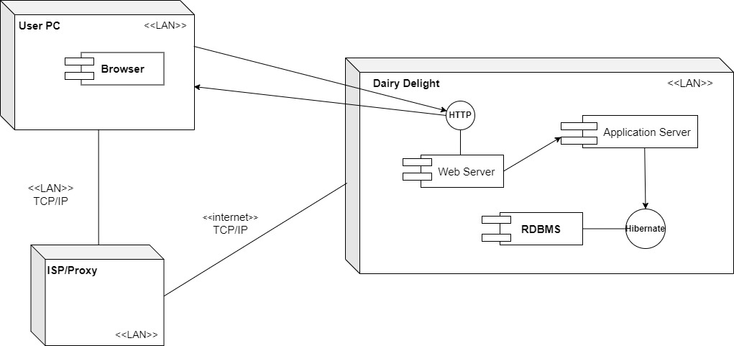

**Screenshots:**

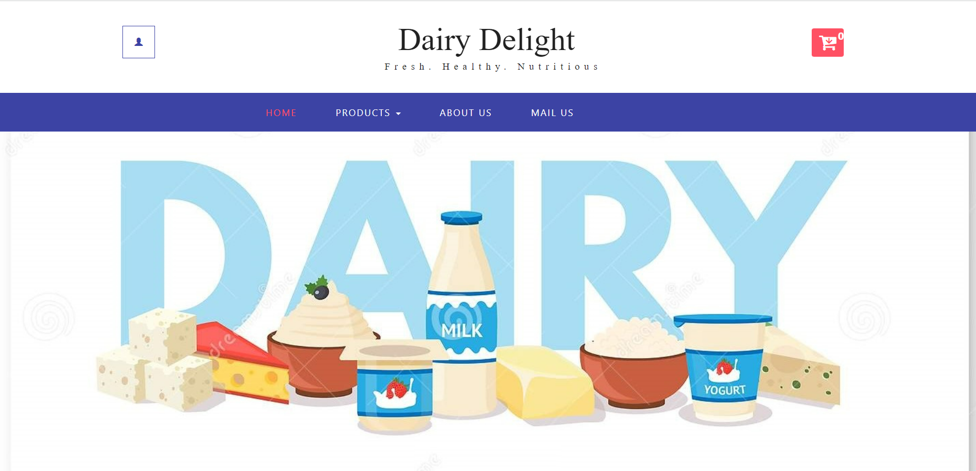

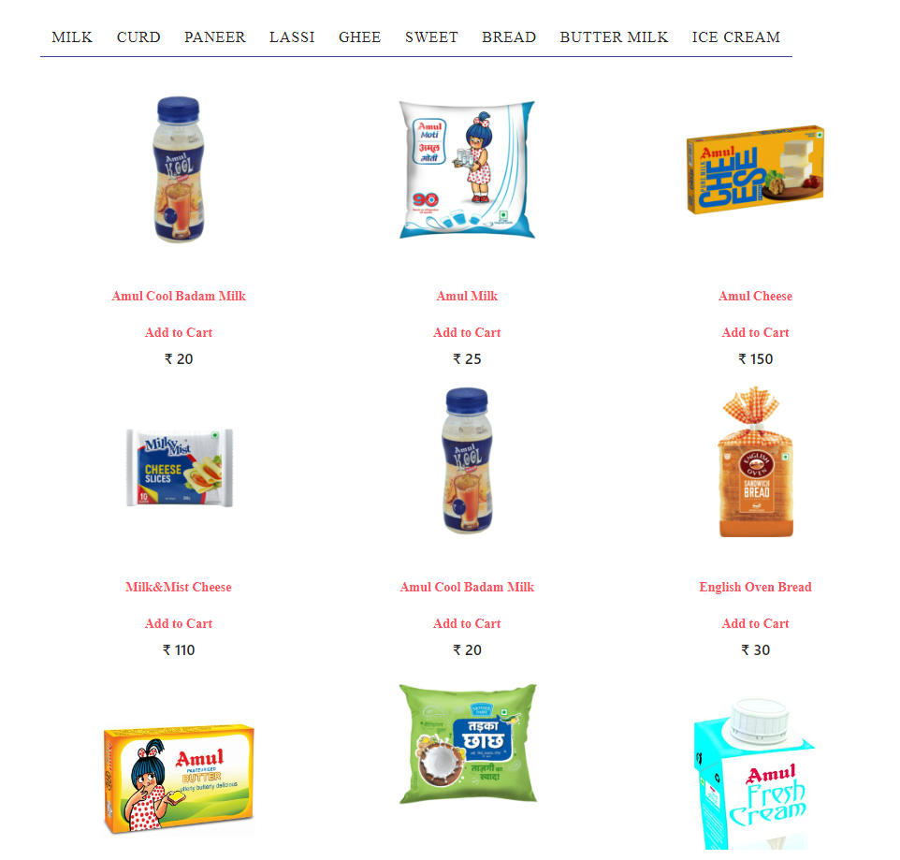

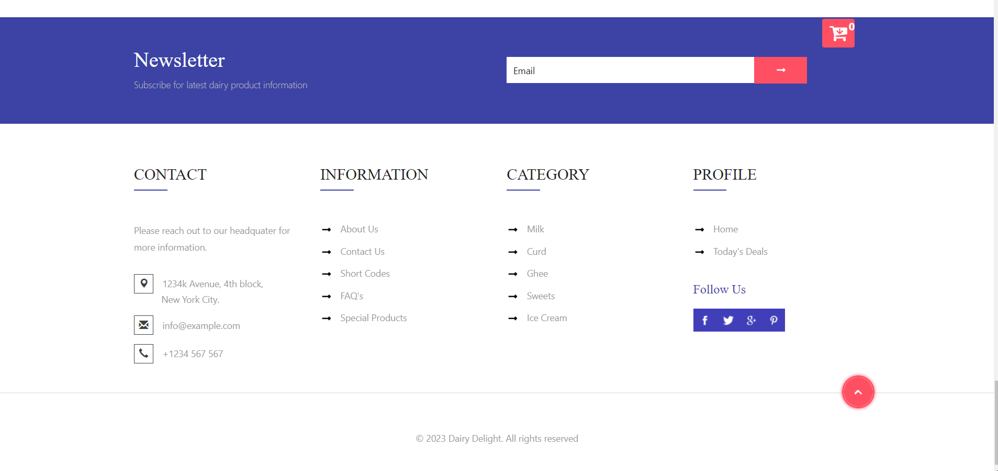

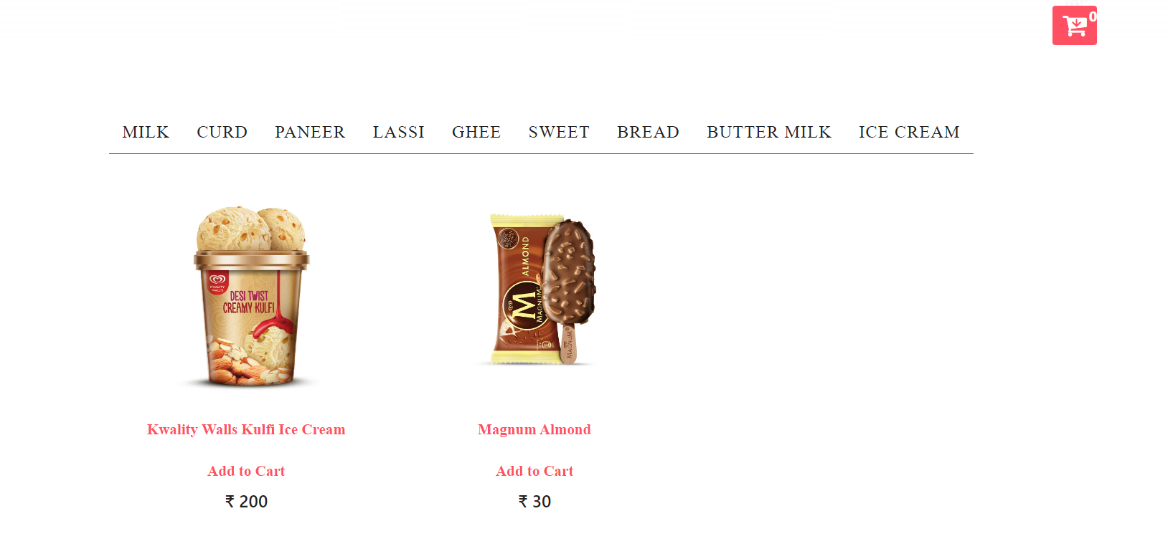

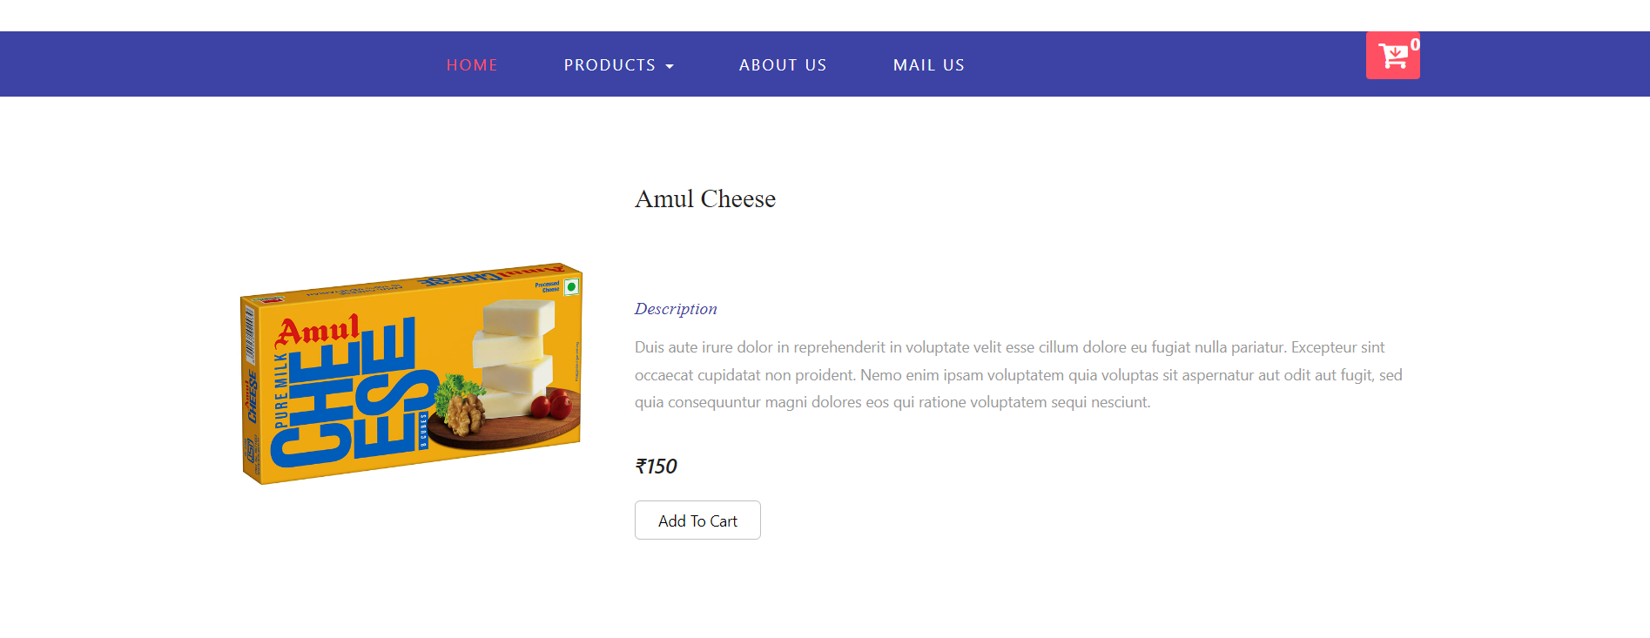

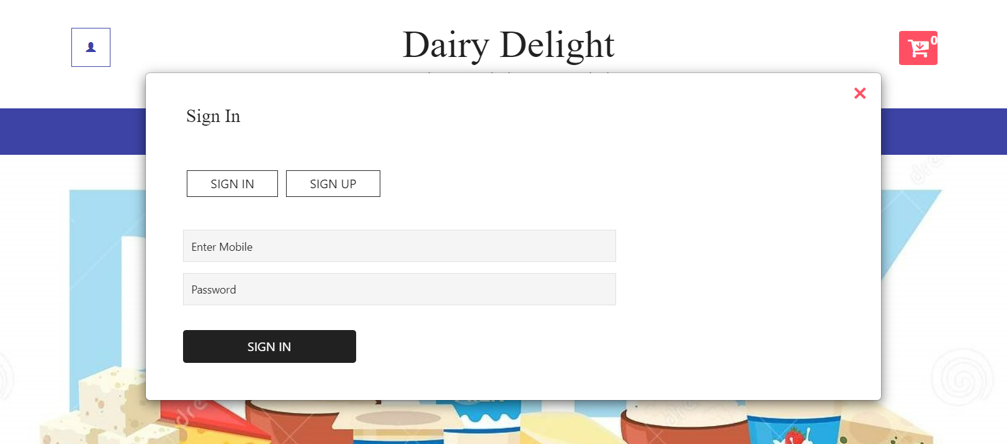

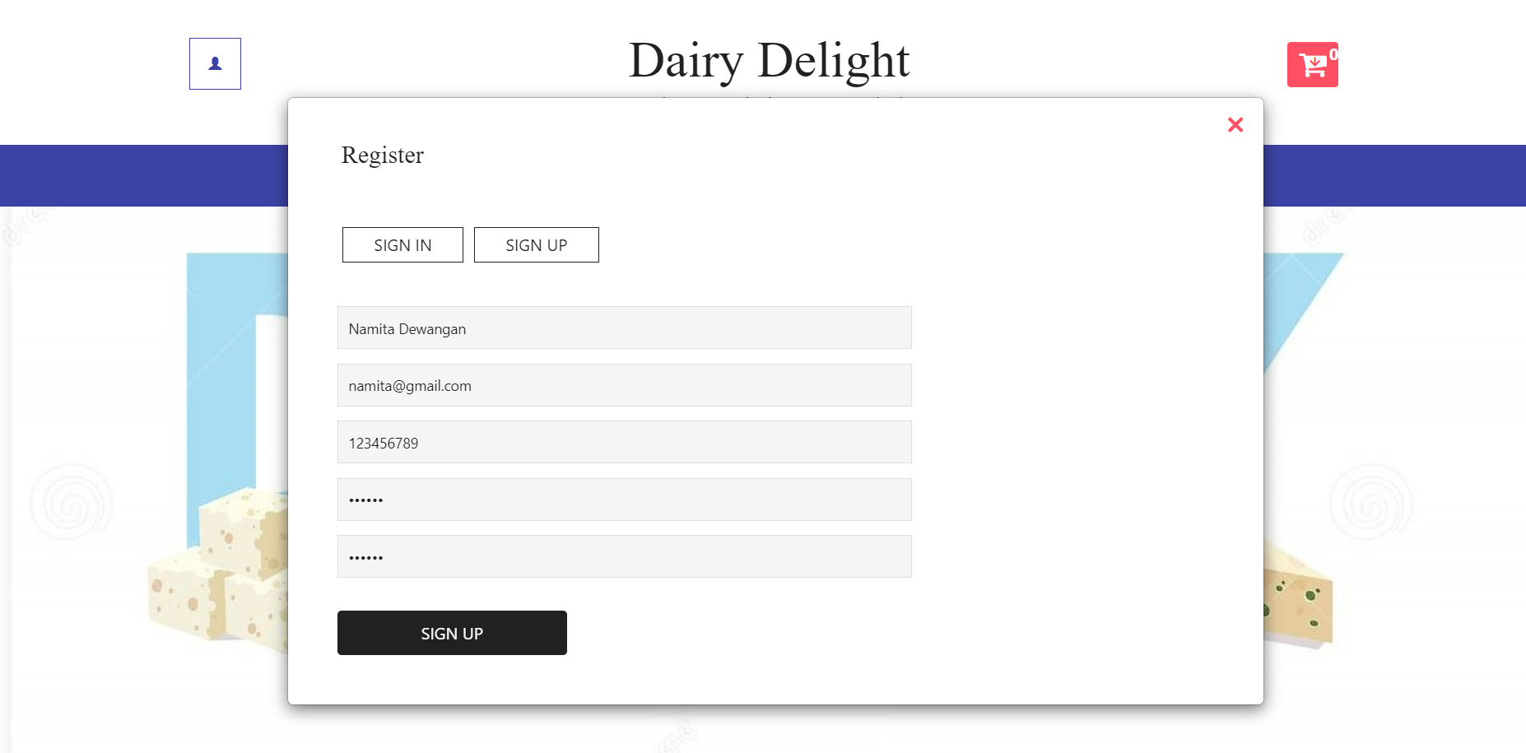

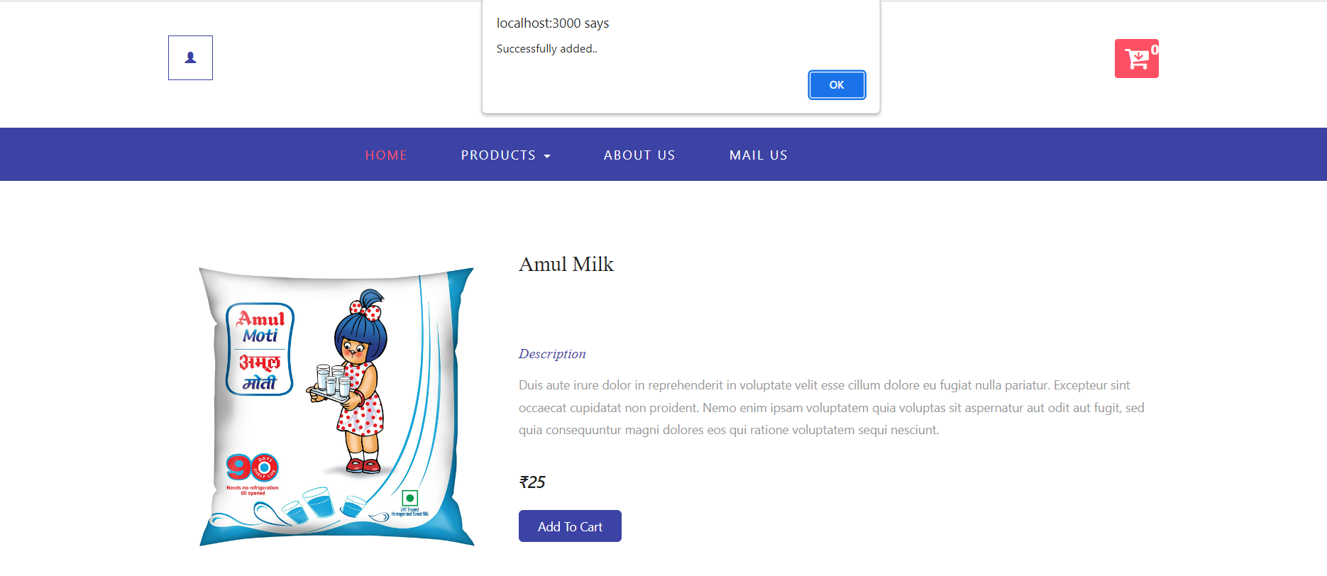

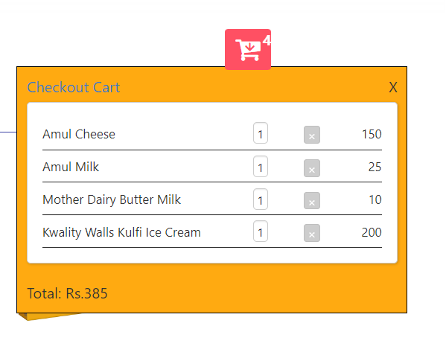

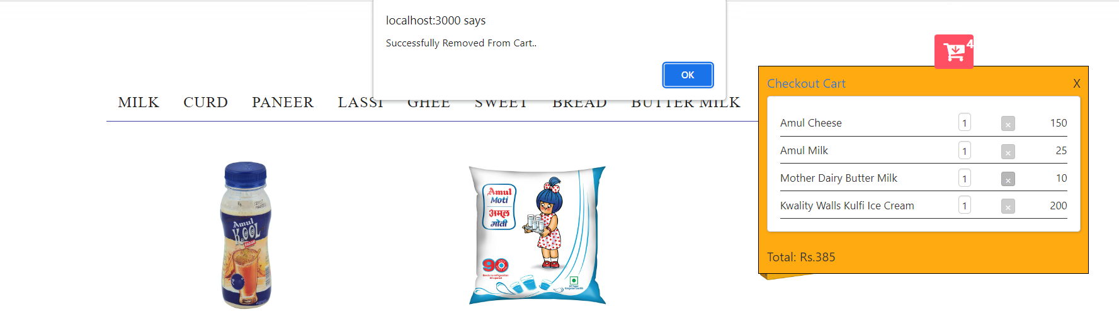

**0th Level DFD**

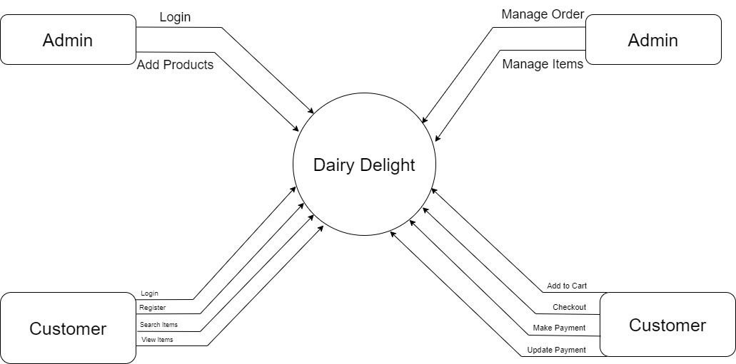

**Class Diagram**

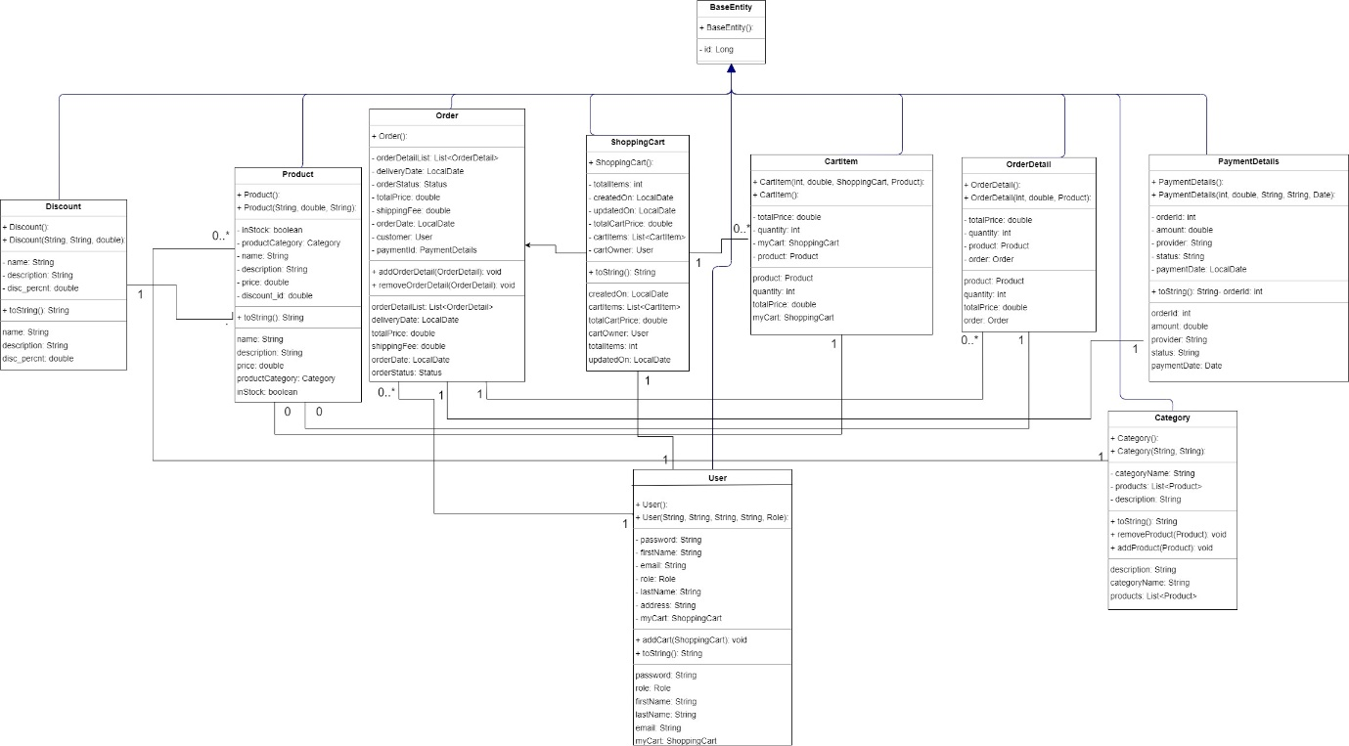

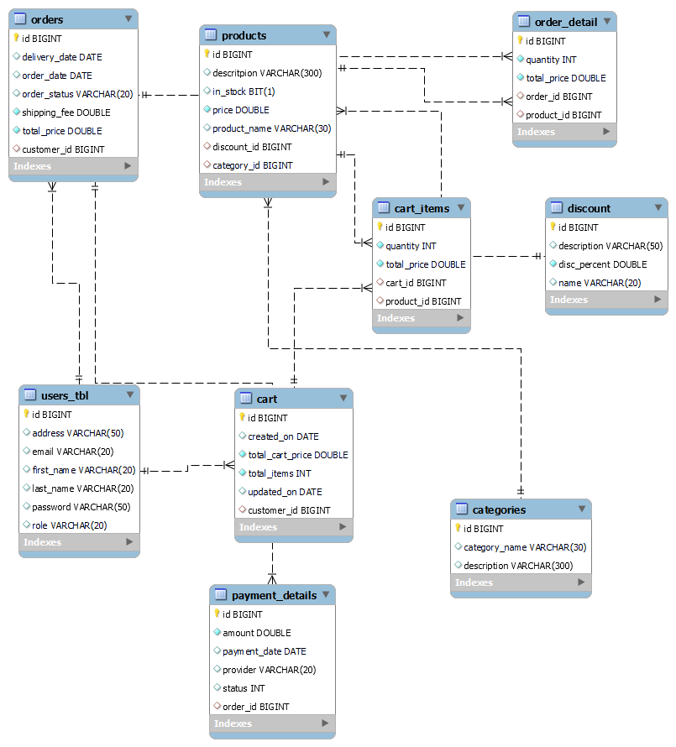

**E-R Diagram**

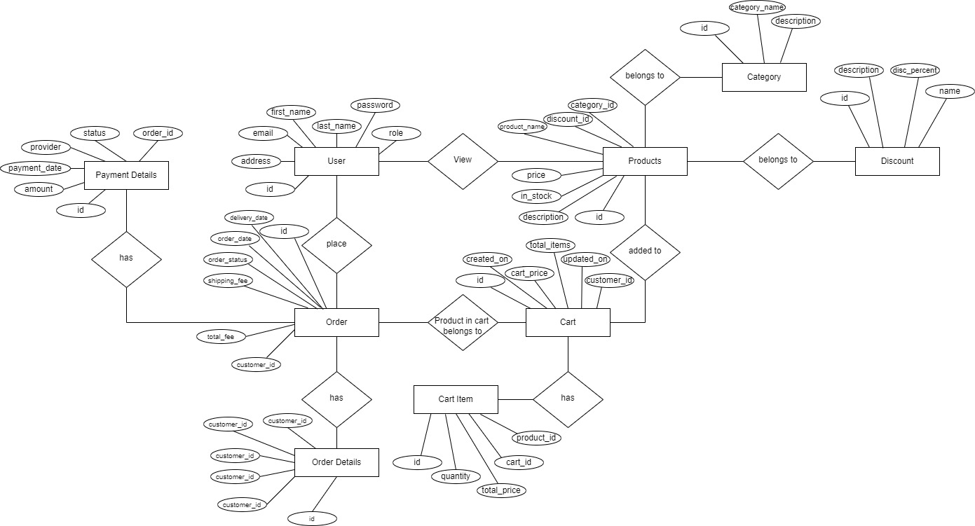

**Database Table Structure**

User table:

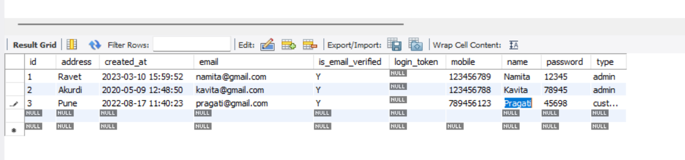

Category Table:

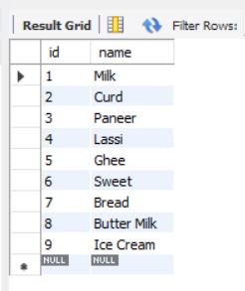

Products Table:

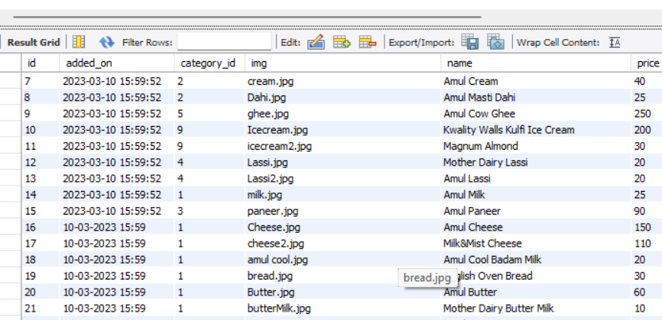

Add to cart:

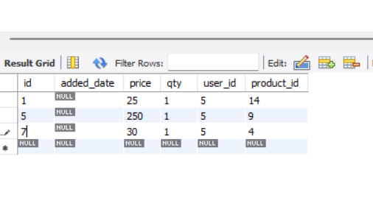

Orders:

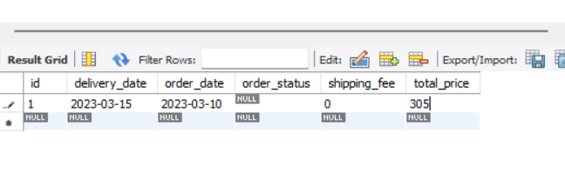

Order Details:

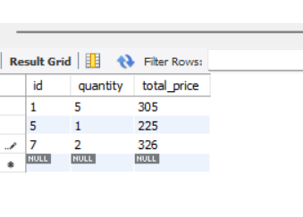

Checkout cart:

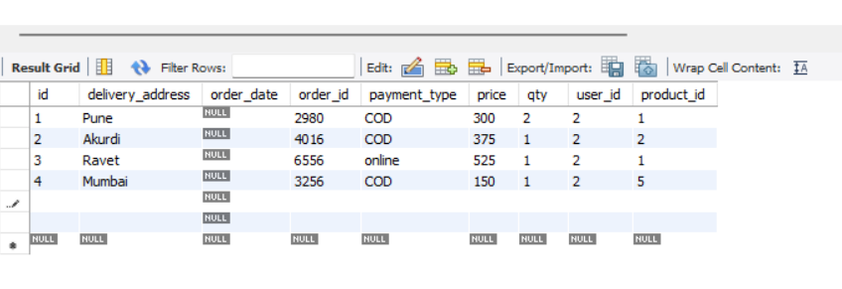

Payment Details:

